PROJECT REVIEW 3
AuxFlow: Static Analysis for Multi-Pass Document Compilation
1. Project Details
Project Title | AuxFlow: Static Analysis for Multi-Pass Document Compilation
Student Name(s) | Upayan Mazumder
Register Number(s) | 24BDS0367
Programme / Branch | B.Tech CSE (Data Science)
Project Guide | Banupriya R
Review Date | 31 October 2026

2. Project Overview
AuxFlow is a static analysis tool for LaTeX documents that need more than one compilation pass. It parses the source, builds the Auxiliary Reference Graph (ARG), and classifies the document as CERTIFIED, BENIGN_CYCLIC, AMPLIFYING, or UNKNOWN before the engine runs. For a certified document it predicts the engine run count. A runtime verifier then checks the prediction against the real engine.
Review 2 covered the front end and the IR (Phases 1 to 7). This document covers Phases 8 to 16: graph analysis, classification, build planning, runtime verification, and the evaluation.
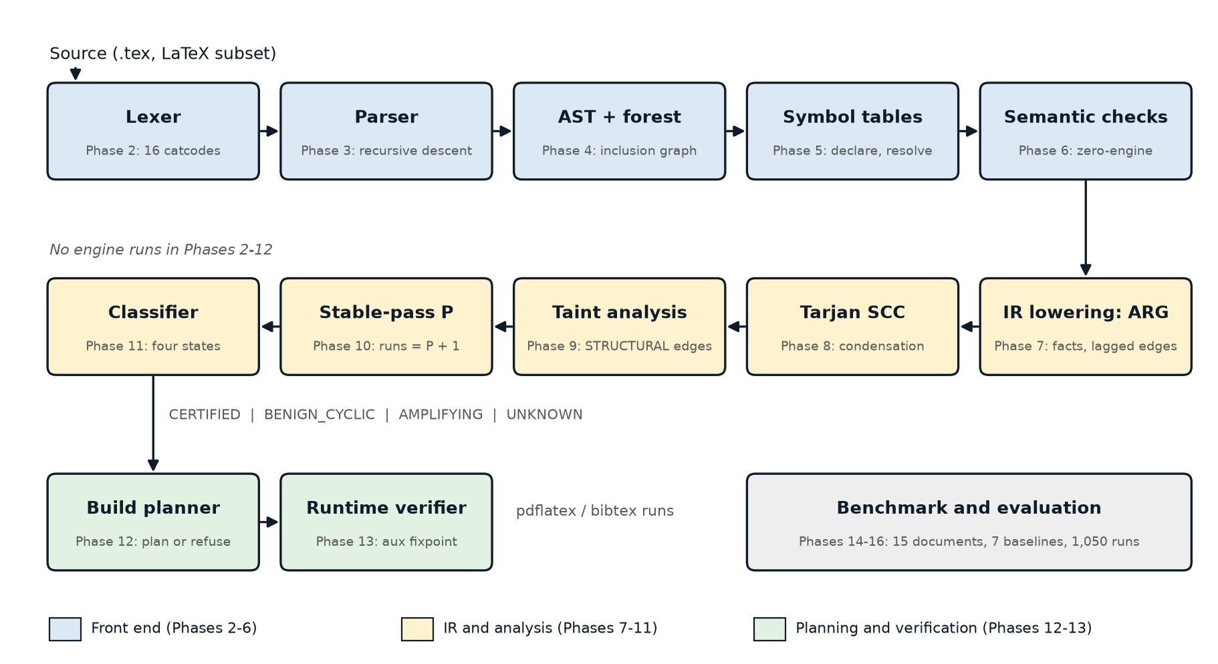
Figure 1. AuxFlow compiler pipeline. Phases 8 to 16 are the subject of this document.
3. Implementation Status
Progress: 16 of 16 implementation phases complete (100% of the implementation plan).
Phase | Module | Function
8 | auxflow.analysis.scc | Iterative Tarjan SCC, condensation graph, cycle classes AMPLIFYING / UNKNOWN_CYCLE / BENIGN
9 | auxflow.analysis.taint | Seeds from values read in loop bounds and conditions, worklist propagation, STRUCTURAL edges to CONTENT_VOLUME
10 | auxflow.analysis.stable_pass | Stable-pass number P per fact on the condensation, predicted runs P + 1
11 | auxflow.analysis.classify | Four-state classifier and source-located diagnostics, auxflow classify
12 | auxflow.planner | Build plan: reachable files only, bibtex only with citations and a bibliography, derived run count, refusal of AMPLIFYING
13 | auxflow.runtime | Normalised auxiliary records, fixpoint check, prediction-miss records, auxflow run
14 to 16 | bench/ | 15-document corpus, 7 baselines, ground truth, 1,050 containerised runs, evaluation report

Build planner safety rule:
Only a CERTIFIED plan uses the derived run count. Every other executable state uses at least three engine runs, and an assertion in the planner enforces this. An AMPLIFYING document gets no plan unless the user passes --force, which runs it under a cap of six runs.
Runtime verification:
The verifier normalises each auxiliary file into an order-independent set of records and compares the state after run k with the state after run k-1. Rerun warnings miss changes in generated lists, so the verifier does not use them. When a certified document needs more runs than predicted, the verifier records a prediction miss.
Code and quality figures:
- About 3,930 lines of implementation code in 41 modules, and about 4,080 lines of test code in 46 files. No third-party runtime dependencies.
- 245 tests pass and 1 is skipped. mypy --strict reports no issues in 41 source files. ruff reports no lint issues in src, tests, and bench.
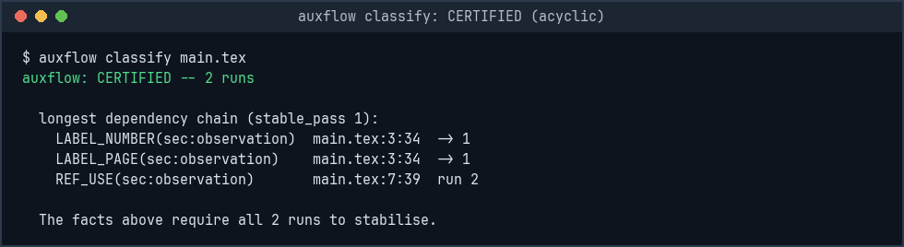
auxflow classify on a CERTIFIED document
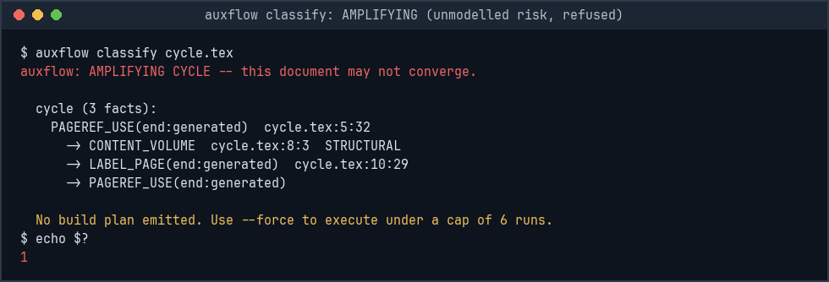
auxflow classify on an AMPLIFYING document: no plan
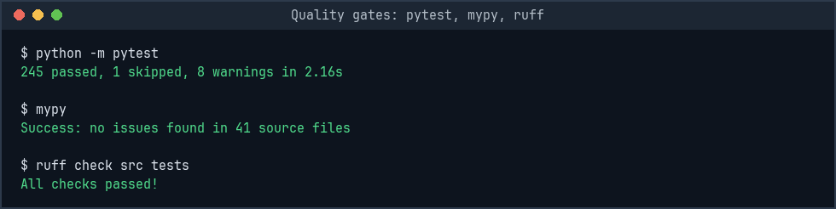
Test suite, strict type check, and lint
4. Evaluation and Results
Setup:
15 benchmark documents (b01_plain to b15_ibid) cover the non-convergence mechanisms M1 to M9, including a realistic multi-chapter thesis. Seven baselines were measured: A (fixed three runs), B (rerun warnings), C (checksum), C' (inputs), C'' (read/write set), D (AuxFlow static), and E (AuxFlow static plus runtime verification). Each document and baseline ran ten times in a pinned Docker image with one CPU and no network: 1,050 runs in total. Ground truth N* comes from eight unconditional engine passes, independent of every baseline.
Gate 1, classification separation: PASS
Document | Expected | Observed
b08_cycle | AMPLIFYING | AMPLIFYING
b05_toc | not AMPLIFYING | CERTIFIED
b11_width, b12_float, b13_varioref | CERTIFIED (declared false negative) | CERTIFIED
b07_footnote, b15_ibid | UNKNOWN | UNKNOWN

All 15 documents classified exactly as expected.json predicted before implementation.
Gate 2, run-count bound (EC1): PASS
Document | Predicted N | Ground truth N* | N >= N*
b01_plain | 1 | 1 | yes
b02_backref | 2 | 2 | yes
b03_fwdref | 2 | 2 | yes
b04_chain | 3 | 2 | yes
b05_toc | 3 | 3 | yes
b06_bib | 4 | 3 | yes
b09_thesis | 4 | 3 | yes
b11_width | 2 | divergent(8) | no (declared)
b12_float | 2 | divergent(8) | no (declared)
b13_varioref | 2 | divergent(8) | no (declared)

The only three violations are the three documents declared as false negatives before implementation. There are no undeclared violations.
Findings:
- Baseline A reports success on all six non-convergent documents (b08, b10, b11 to b14) and is wrong on each of them.
- Baseline B reports CONVERGED after one run on b10_random in all ten repetitions. Ground truth for b10_random is divergent(8).
- On b11_width, b12_float, and b13_varioref, static analysis alone (D) certifies the document wrongly, as declared. Baseline E keeps running past the prediction and reports cap_exceeded at six runs in all 30 repetitions.
- latexmk and latexrun also fail to converge on b11_width, b12_float, and b13_varioref. Tectonic stops b08_cycle at its 6-pass limit, and Typst rejects a port of b08_cycle with 'loop seems to be infinite'.
- Static analysis (D) finishes in under 10 ms on every document. The largest case, b09_thesis with 91 facts and 73 edges, has a median of 9.65 ms.
- b01_plain needs two runs under E although N* is 1. pdfTeX writes \@abspage@last on every run, so the verifier needs a second run to see two equal states.
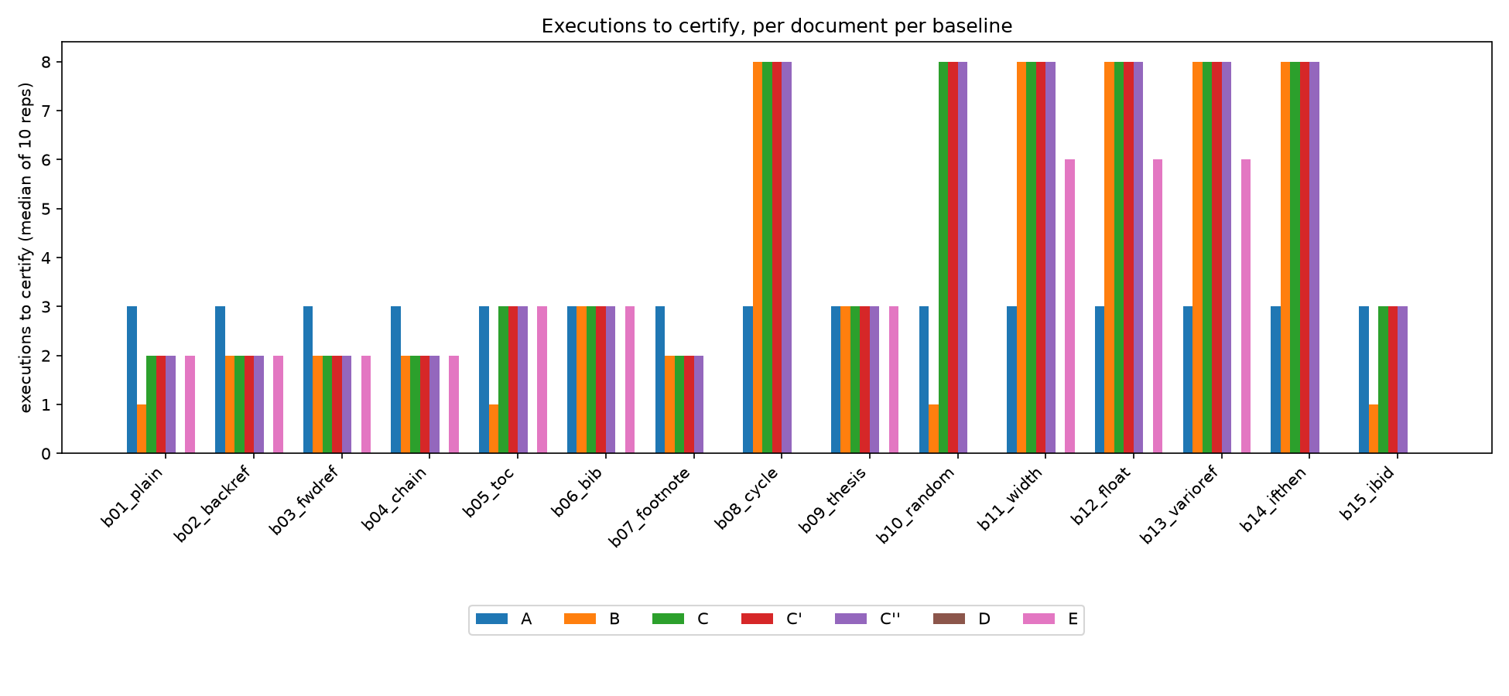
Engine executions to certify, per document and baseline
Limitations:
- The corpus has 15 documents, and most are synthetic. All runs used one machine.
- The static model does not see line-break width, float placement, or varioref text feedback. Runtime verification catches these cases.
- Tectonic ran fully offline on only b01_plain and b08_cycle. The latexmk and latexrun cross-check covers all 15 documents.
5. Novelty
- Static classification of multi-pass convergence from source, before any engine run. latexmk, latexrun, and Tectonic decide only after each run.
- The exists/value split in the IR, which keeps ordinary documents acyclic.
- Four states that separate value-only cycles from cycles that change how much content is generated.
- A static prediction paired with a runtime verifier that records prediction misses.
6. Remaining Work and Future Scope
- Write the research paper. The paper/ directory has the section structure.
- Model more packages, so fewer documents classify UNKNOWN.
- Prove a run-count bound for benign cycles.
7. Reproduction
bash bench/demo.sh runs the full pipeline on b08_cycle and b11_width and compares each verdict with the published measurements. Every number in this document comes from bench/results/published/ and docs/EVALUATION-REPORT.md.

